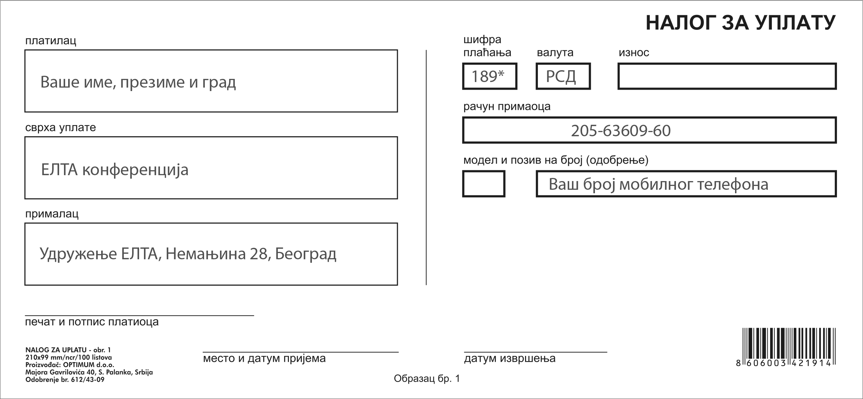

*289 via NetBanking

All fees payable to ELTA account:
205-63609-60 Komercijalna Banka, Udruženje nastavnika engleskog jezika – ELTA
For conference registration cancellations a fee of 2.000 RSD will be deducted. No refunds can be given for cancellations received after 1 April 2019.

All payments after 15 April 2019 will be made at the Conference.

